***Milestone 1 Start***

Use this template file to organize screenshots demonstrating completion of each rubric item. Your screenshots do not need to match the example ones. You will also need to meet with your instructor during class time to demonstrate your working Virtual Machines and answer any questions they may have to receive your mark.

* We will be naming the Azure nested servers [LastInitial][FirstName] followed by an indicator of the role the server plays within the domain followed by an incremental number. The roles within the environment will be DC (domain controller), DM (domain Member), RODC (read only domain controller) and Client.
  + **The Conventions below apply to both the Virtual Machine names and the Computer name inside the Virtual machine**
  + An example of the naming convention is *[LastInitial][FirstName]DC1* and *[LastInitial][FirstName]DM1* for your servers. The client (Milestone 2) should be *YourFirstNameClient1*. (The member server and client will be added throughout the project.) **Truncate as needed to be 15 characters or less.**

|  |  |
| --- | --- |
| * Server VM names are correct | 2 |

Include a screenshot of your host’s Hyper-V Manager with the child VMs correctly named.

* Install and configure (**Check out Windows Server 2019 reference materials section**) one Windows Server 2019 Standard (GUI / Desktop Experience) server
* The second server will be *installed and configured later* using WDS, it will also be a Windows Server 2019 (GUI / Desktop Experience) server
* Set the Windows updates to ‘Manual’ after you have configured your servers
* Use best practices for assigning IP addresses (Static for servers and dynamic for clients.) Use the 172.16.0.0/16 range.

|  |  |
| --- | --- |
| * Server Computer names are correct | 2 |
| * Windows Updates have been set to Manual | 2 |
| * Servers have appropriate static IP | 2 |

Include a screenshot showing the Server Manager page of the first child VM, the IP address and Windows Update status should be visible

*After installing it using WDS later on,* include a screenshot Server Manager page of the second child VM, the IP address and Windows Update status should be visible

|  |  |
| --- | --- |
| * External DNS Resolution works on both servers | 2 |

Include screenshots showing the results of “nslookup [some 3rd party page]” on both VMs

* All servers in the environment should have one 30 GB drive and one 20 GB drive installed. Configure these as drive C and drive D respectively **(change the DVD drive’s letter if needed)** with NTFS formats. All operating system files should be on the C drive. All user files should be on the D drive. The D drive will be used later in the project

|  |  |
| --- | --- |
| * Servers have 30 GB C: and 20 GB D: NTFS Drives | 2 |

Include screenshots showing the C and D drives of the child VMs, this could be in the VMs setting or through the VMs file explorer.

* Install the WDS role on your server
* Configure an Install Image for a Windows Server 2019 Standard Desktop Experience machine
* Using the image you created in the last step, perform a network install of a second Windows 2019 Desktop Experience server.

|  |  |
| --- | --- |
| * DHCP Role Installed | 1 |
| * Internal Network scope created from 172.16.0.50 to 172.16.0.100 | 1 |
| * WDS Role Installed | 1 |
| * Install image for Windows Server 2019 Standard Desktop created | 1 |
| * Network install works for WDS Image | 1 |
| * Member Server created (through WDS) and configured | 1 |

Include a screenshot showing the DHCP role on your DC1 VM.

Include a screenshot showing the Internal Scope (IP addresses 172.16.0.50 to 172.16.0.100) on your DC1 VM.

Include a screenshot showing the WDS role on your DC1 VM.

Include a screenshot showing the WDS install or boot image on your DC1 VM.

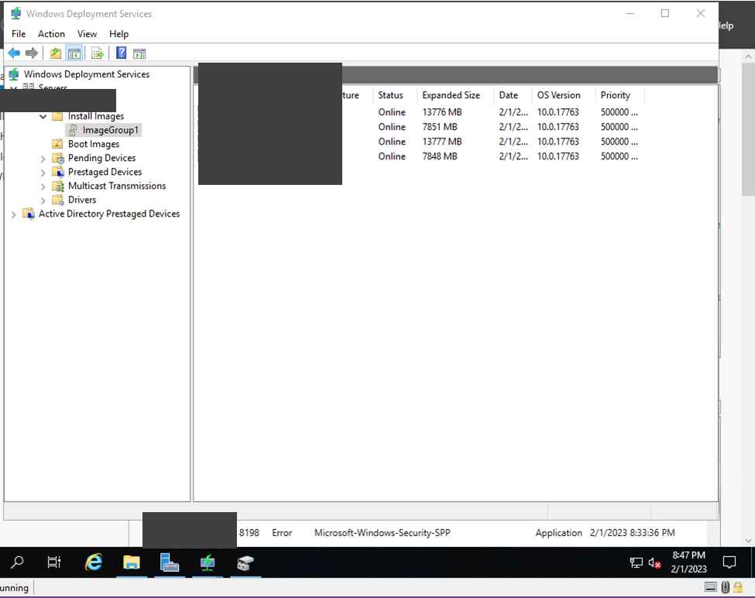

Include a screenshot showing a Network install on a child VM, (you can create a temporary VM and screenshot that one if you already created all the VMs)

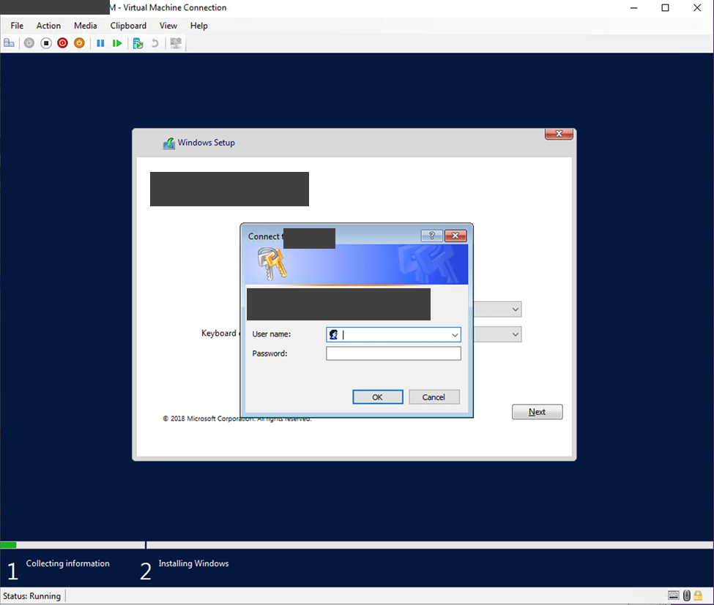

* Make one of the servers your primary domain controller with a domain name of *YourLastName*Project.local. **Truncate as needed to be 15 characters or less.**

|  |  |
| --- | --- |
| * DC1 Server Installed and configured | 1 |
| * DC1 Server is a Domain Controller (DC) | 1 |
| * Domain name is correct | 1 |

Include a screenshot of this VMs Server Manager window showing the Domain Controller Role, along with the name of the domain.

* Configure the second server as a Member Server

|  |  |
| --- | --- |
| * Member server added to the domain | 1 |

Include a screenshot showing the Member Server in the domain

* Create a Server Group in Server Manager on the GUI server and add both servers to this group. Make sure you can access disk management for both servers from the Server Group.

|  |  |
| --- | --- |
| * Server Group Created. Disk Management can be accessed on both servers through the Server Group | 2 |

Include a screenshot showing the Server Group with both servers being members.

Include a second screenshot showing access to the disk management.

* Create and maintain checkpoints for your child VMs to protect against crashes or data loss.

|  |  |
| --- | --- |
| * Backup Plan in Place and Backups of both servers made | 2 |

Include a screenshot showing at least one production checkpoint for each of your virtual machines.

## Powershell Script

* Create a folder off the root of Drive C that you can use to store all of your Powershell scripts
  + Again, it is recommended that you test out your Powershell script on your local machine to save Azure time.

|  |  |
| --- | --- |
| * Powershell Script folder created on drive C of DC1 | 1 |

Include a screenshot of this folder.

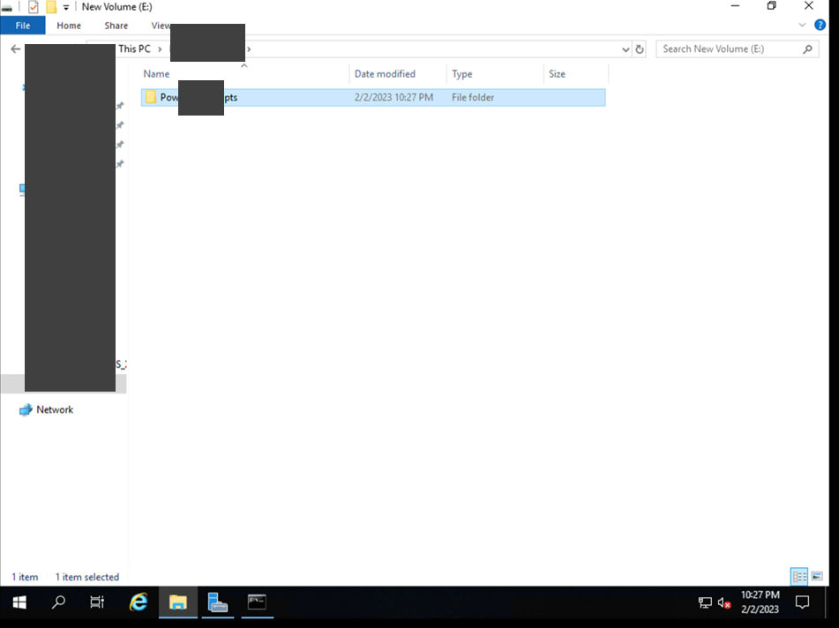

* Create a Powershell script that will query and then save some of your system information to a file.
  + The script should store the date that your script runs so that you can use it for comparison purposes.
  + The script should query all of the servers in your environment using the role indicator designation (Ex: All, Controllers, Members, Clients, etc).
  + Check to make sure that any server name you query exists so that the script runs without errors.
  + Include the following information in your script:
* Processes running on the system
* All environment variables for user and for system
* The system processor
* Computer system information such as name and domain membership
* The logical disks on the system– with disk size and free space information
* A list of the shares on your drives
* The configuration of your network adapter

|  |  |
| --- | --- |
| * PowerShell script can query list domain servers by designation (three types minimum). No errors encountered if server not present/online. | 4 |
| * PowerShell Script writes the date run to the file | 1 |
| * All information saved: * running processes, environment variables for user and system, processor, computer system information, logical disks with total and available sizes, list of shares, network adapter configuration | 10 |
| * Coding Best practices followed | 2 |

Include a screenshot of running your PowerShell script, as well as a screenshot of the script itself.

**Also submit your PowerShell script files , as well as the output file(s) to the Learn Dropbox**